The TCA cycle is the central metabolic pathway for the production of ATP/energy.

Each step is controlled by an enzymatic reaction.

Develop a quantitative model for each component of the first 3 steps (see data below).

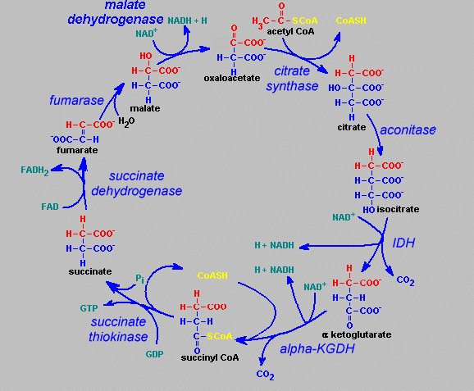

Enzymatic reaction (M-M) model dC/dt = - VM*C/(Km+C)

Vm(mmol/min) Km (mmol)

Citrate synthase 19 28

Aconitase 35 32.2

Isocitrate dehydrogenase 5 2.2

Components initial concentration (mmol)

Acetyl CoA 50

Citrate 0

Isocitrate 0

 ketoglutarate 0

Develop a model and solve for the concentrations of the components vs. time for 0<t<20.

Solutions

Since mass is conserved, do a mass balance on the various components

For example, oxaloacetate is









|  |  |  |  |  |  |  |  |  |
| --- | --- | --- | --- | --- | --- | --- | --- | --- |
| TCA cycle problem solved using Euler's method | | | | |  |  |  |  |
|  |  |  |  | Vm | 19 | 35 | 5 |  |
|  |  |  |  | Km | 28 | 32.2 | 2.2 |  |
| t | Coa | Cc | Cic | Cak | Coa' | Cc' | Cic' | Cak' |
| 0 | 50 | 0 | 0 | 0 | -12.1795 | 12.17949 | 0 | 0 |
| 1 | 37.82051 | 12.17949 | 0 | 0 | -10.9174 | 1.312029 | 9.605385 | 0 |
| 2 | 26.9031 | 13.49152 | 9.605385 | 0 | -9.3102 | -1.02439 | 6.266367 | 4.068222 |
| 3 | 17.5929 | 12.46713 | 15.87175 | 4.068222 | -7.33152 | -2.4374 | 5.377602 | 4.391315 |
| 4 | 10.26138 | 10.02973 | 21.24935 | 8.459537 | -5.09564 | -3.217 | 3.781734 | 4.530904 |
| 5 | 5.165741 | 6.812729 | 25.03109 | 12.99044 | -2.95935 | -3.15264 | 1.515943 | 4.59605 |
| 6 | 2.20639 | 3.660088 | 26.54703 | 17.58649 | -1.38783 | -2.18447 | -1.04505 | 4.617352 |
| 7 | 0.818557 | 1.475618 | 25.50198 | 22.20384 | -0.53967 | -0.99398 | -3.06927 | 4.602916 |
| 8 | 0.278885 | 0.48164 | 22.43272 | 26.80676 | -0.18738 | -0.32843 | -4.03763 | 4.553439 |
| 9 | 0.091508 | 0.15321 | 18.39508 | 31.3602 | -0.06189 | -0.10385 | -4.30015 | 4.465892 |
| 10 | 0.029615 | 0.049358 | 14.09494 | 35.82609 | -0.02007 | -0.03349 | -4.27138 | 4.324944 |
| 11 | 0.00954 | 0.015865 | 9.82356 | 40.15103 | -0.00647 | -0.01076 | -4.06789 | 4.08513 |
| 12 | 0.003069 | 0.005101 | 5.755667 | 44.23616 | -0.00208 | -0.00346 | -3.61179 | 3.617338 |
| 13 | 0.000987 | 0.00164 | 2.143872 | 47.8535 | -0.00067 | -0.00111 | -2.46592 | 2.467697 |
| 14 | 0.000317 | 0.000527 | -0.32204 | 50.3212 | -0.00022 | -0.00036 | 0.858002 | -0.85743 |
| 15 | 0.000102 | 0.000169 | 0.535959 | 49.46377 | -6.9E-05 | -0.00011 | -0.97929 | 0.979471 |
| 16 | 3.28E-05 | 5.44E-05 | -0.44333 | 50.44324 | -2.2E-05 | -3.7E-05 | 1.261902 | -1.26184 |
| 17 | 1.05E-05 | 1.75E-05 | 0.818573 | 49.1814 | -7.1E-06 | -1.2E-05 | -1.35588 | 1.355894 |
| 18 | 3.39E-06 | 5.63E-06 | -0.5373 | 50.53729 | -2.3E-06 | -3.8E-06 | 1.61576 | -1.61575 |
| 19 | 1.09E-06 | 1.81E-06 | 1.078458 | 48.92154 | -7.4E-07 | -1.2E-06 | -1.64476 | 1.644764 |
| 20 | 3.5E-07 | 5.81E-07 | -0.5663 | 50.5663 | -2.4E-07 | -3.9E-07 | 1.7332 | -1.7332 |